Wavemaking
From Discrete Samples Part II
April 29, 2014
David Houston
ENGR 267

Abstract
This lab took the very basic concepts of MATLAB and expanded them into a more useful toolbox by which higher order tasks could be achieved. We went about synthesizing mixing, modulation, and the decay rate of sinusoids in order to produce the desired results. We finished the lab utilizing the user input functions to make a general code that would work for any general set of input functions.

Procedure

Task 1
It was first observed to take the pervious labs signals of 40 and 20 samples and “mix” them together in order to produce an oddly shaped wave as seen below.
n = 1:120;

cos_val = cos(2*pi*n/120);

cos_40 = cos_val(1+mod(3*n,120));
cos_20 = cos_val(1+mod(6*n,120));

cos_sum = cos_40 + cos_20;

subplot(311)
plot(n,cos_40)

subplot(312)
plot(n,cos_20)

subplot(313)
plot(n,cos_sum)
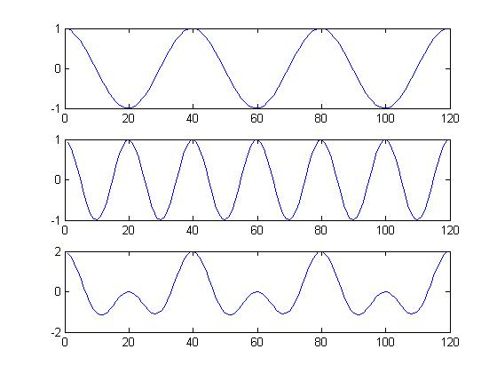

Task 2
Mixing signals proved to be quite easy, and thusly so was modulating the signals. We took the mixed signal which we generated and modulated it with another signal with had a period of 10 samples/cycle as seen below.
cos_10 = cos_val(1+mod(12*n,120));

cos_mod = (cos_sum).*(cos_10);

plot(n,cos_mod)

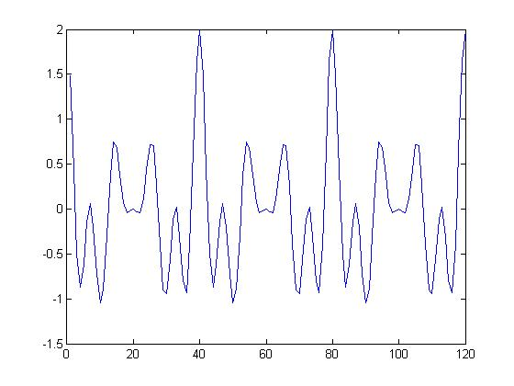

Tasks 3
We were then asked to model a decaying function based on the opinion that we will use it for future assignments. The product can be view below.

decay = ((2.^(n/40)).^-1);

plot(n,decay)

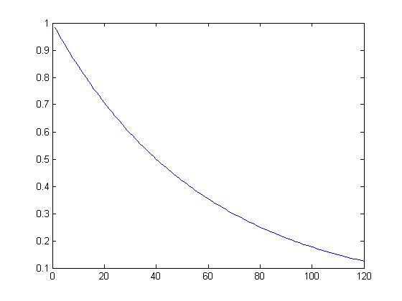

Tasks 4
After generating the decay function we modulated it with the modulated function in order to produce a modulated function that had a half-life of 40 samples.
cos_decay = decay.*cos_mod;

subplot(211)
plot(n,cos_mod)

subplot(212)
plot(n,cos_decay)

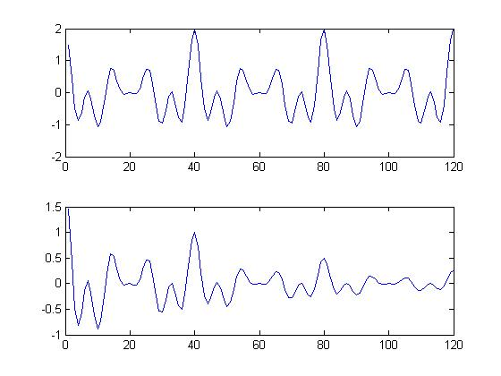

Task 5 & 6
After completing the various tasks, we devised a system which allowed the user to input a sinusoidal function with a set amount of samples and produce a function which had a specified half-life associated with it. An example of user input is displayed below
final = input ('Enter number of samples: ');
n = 0:final;

signal = input('Enter Signal Table w/ variable "n": ');

plot(n,signal)

halflife = input('Enter Halflife (in samples): ');

decay = ((2.^(n/halflife)).^-1);

cos_decay = decay.*signal;

plot(n,cos_decay)

% User Input
Enter number of samples: 256
Enter Signal Table w/ variable "n": 10*sin(2*pi*n/64)
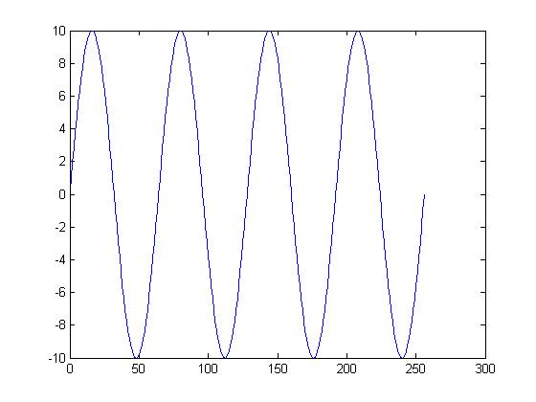
Enter Halflife (in samples): 35
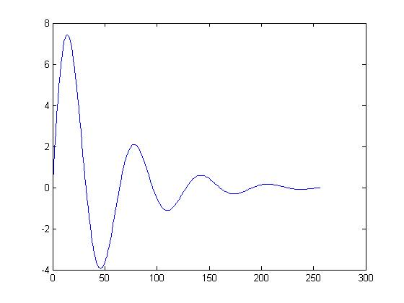

Conclusion
This lab introduced us to the concepts of mixing, modulating, decay theory, and user input. The vast scope of this lab was perfect our signal processing skills in order to generate desired output signals.
We first took two signals and “mixed’ them together, which generate a mixed frequency wave. Next, we then took that wave and modulated it with another signal of a different frequency, which gave us a substantially altered representation of the original function. We then took a desired a decay function to take off one half of the waves amplitude based on a certain half-life. We then perfected this method to produce a function with allowed us to enter in any type of signal and generate a decayed output.
This lab helped solidify the vast concepts of signal processing and their deeper functionality in MATLAB. Throughout the course of this lab we have honed our programming skills even more and are now able to prompt the user.

